Introduction:

This section focus on relationship of sex ratio and suicide rate.

There are many studies demonstrated that suicide rate of countries have differ in gender, According to Anne Maria Möller-Leimkühler, there’s a a high gender-related vulnerability of young men in Suicide and premature death. To study the correrlation between sex ratio and suicide rate, the dataset had been used is from WHO with the

Phillips Cutright1 and Robert M. Fernquist2 clams that This means that countries with low male rates have small gender gaps and nations with high male suicide rates will have larger gender gaps. However, we found that more countries have show negative correlation than positive.

Study on 91 countries from 1987 to 2016 found that:

Sex ratio: the number of male per 100 female

Suicide rate: the number of people dead because of suicide per 100000 people

Female suicide rate: number of female dead because of suicide per 100000 female

Male suicide rate: number of male dead because of suicide per 100000 male

Gender gap: male suicide rate-female suicide rate(Phillips Cutright1 and Robert M. Fernquist2:In the remainder of this article the term ‘‘gender gap’’ refers to the difference in the male minus the female suicide rate;)

1/ From the dataset we found that male is generally more vulnerable than female in suicide. There is no exception in the 91 countries

Add figure here

2/sex ratio at birth is an index describe the sex structure of a population, sex ratio at birth is defined as the number of male of per 100 female

(<https://demography.subwiki.org/wiki/Sex_ratio_at_birth>)

In this section, we define sex ratio as same as sex ratio at birth, and exam on the correlation between sex ratio and suicide rate. The result is

Table

Positive correlation 22%

Negative correlation 30%

No correlation 48%

3/ study the correlation between sex ratio and suicide rate of male or female. Found that some countries are in no correlation class show relatively significant correlation on a specific gender. For example, Argentina, the correlation between sex ratio and suicide rate is -0.143392, and p value is 0.458044, seems there is no correlation. However, the correlation of female suicide rate and sex ratio is 0.767535 and p value is 0.000001. For male the numbers are -0.467747 and 0.010508.(see the numbers on the table below) that means both female and male suicide rate have related with sex ratio, but in an opposite way. And united stares of America

Table

Argentina

Example of differences in total correlation and gender correlation

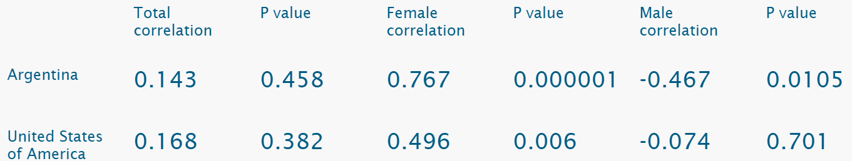

Except Argentina, the distribution of female correlation and male correlation are generally same

Figure—distribution sex correlation

4/according to World Bank Country and Lending Groups in the 91 countries, 50 countries are HIGH-INCOME ECONOMIES, 30 countries are UPPER-MIDDLE-INCOME ECONOMIES, 8 counties are LOWER-MIDDLE-INCOME ECONOMIES and 3 countries miss this value.

1. In the HIGH-INCOME ECONOMIES, generally more female population than male, 40 countries have sex ratio<100, 10 countries have sex ratio>100
2. In the 10 HIGH-INCOME ECONOMIES which sex ratio>100, Republic of Korea, United Arab Emirates and Oman show negative correlation between sex ratio and suicide rate. Except the three counties, other 7 countries all show no correlation.
3. Except the countries show no correlation, most of countries show negative correlation between sex ratio and suicide rate, the trends is more significant in HIGH-INCOME ECONOMIES countries

Positive correlation 18%

Negative correlation 38%

No correlation 44%

5/ gender gap

Positive 17 19%

Negative 27 29%

No 47 52%

Summary

Apparently there is gender differences in suicide rate. In terms of the correlation with suicide rate and sex ratio, over all, more negative correlation could be seen. But that might because there are more HIGH-INCOME countries in this dataset(50 in 91). Negative correlations are more common in HIGH-INCOME countries. In terms of the relation between gender gap and sex ratio, there are more no correlation rather than positive correlation, which conflict with the research results of Phillips Cutright and Robert M. Fernquist.